EMPLOYEE ISSUE RAISING MANAGEMENT
IN SERVICENOW
Complete Project Documentation
ServiceNow – Studio, Employee Center Application, Custom Table, UI Policies, Dictionary Configuration, Record Producer and Service Portal
Project | Employee Issue Raising Management
Platform | ServiceNow
Primary Interface | Service Portal (Employee Center)
Workflow | Application Setup → Table Creation → UI Policies → Dictionary Configuration → Record Producer → Service Portal → Widgets → Testing

1. Project Overview
The project implements an automated Employee Issue Raising process in ServiceNow using a custom scoped application. Employees submit issues through a dedicated Service Portal built on the Employee Center, the request data is captured in a custom table, category and subcategory values are controlled through dependent-field configuration, business rules are enforced through UI Policies, and the submission experience is enhanced using a Record Producer with custom Service Portal widgets.

Project Lifecycle
- Requirement analysis and planning
- Application and backend development and configuration
- UI/UX development and customization
- Business rule enforcement, testing and validation
- Deployment, documentation and final presentation

Evidence Summary
The implementation evidence in this document is based on the ServiceNow Studio configuration steps performed for the Employee Center application, the custom table and field setup, UI Policy and dictionary configuration, Record Producer variables, and the Service Portal and widget development. Screenshots should be placed under the phase where they demonstrate the corresponding implementation or output.

2. Phase 1 – Requirement Analysis & Planning
Phase 1 focused on understanding the Employee Issue Raising lifecycle, identifying the functional scope, defining stakeholders, and planning the execution sequence.

2.1 Business Objectives
The objective is to automate employee issue submission in ServiceNow and provide a structured, self-service process for raising issues, enforcing mandatory information, and routing the request through a dedicated Employee Center portal.

2.2 Functional Scope
The solution supports Employee Issue submission through the Service Portal, structured data capture using a custom table, category-driven subcategory selection, UI Policy-based enforcement of mandatory and read-only fields, Record Producer-based data entry, and a themed Employee Center portal with custom widgets.

2.3 Stakeholder Mapping
- Employee (Requester) – raises and tracks the issue.
- ServiceNow Administrator – configures the application, table, UI Policies and portal.
- Support / IT Team – reviews and resolves the raised issue.
- QA / Project Team – validates the end-to-end submission and portal experience.

2.4 Execution Roadmap
Application Creation → Table & Field Configuration → UI Policy Configuration → Dictionary / Dependent Field Configuration → Record Producer & Variables → Service Portal Configuration → Widget Development → Page Design → Testing & Validation.
Phase 1 is planning-oriented; therefore the project evidence is documented primarily as requirements and scope rather than implementation screenshots.

3. Phase 2 – Application & Table Setup
Phase 2 established the scoped application and the backend table structure used to capture Employee Issue records.

3.1 Scoped Application Creation
An Employee Center scoped application was created in ServiceNow Studio to contain all components of the solution.
- Navigate to All menus → App Engine → ServiceNow Studio.
- Click Create, then select the App option to create a new application.
- Name: Employee Center.
- Scope: Scoped.
- Click Continue.
- Return to the ServiceNow home page and reload; the newly created application appears as the current application.

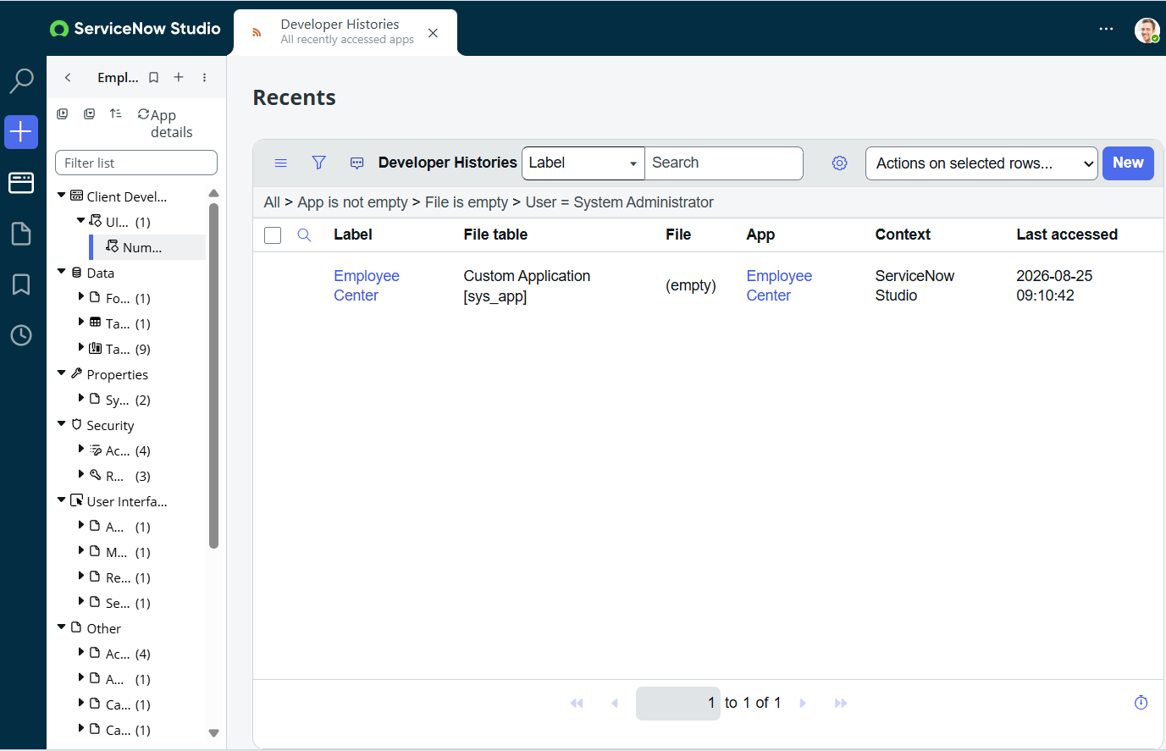

3.2 Custom Table Creation
A custom table was created to store the Employee Issue records, with auto numbering enabled for each submitted issue.
- Navigate to Tables under System Definition and select it.
- Click New in the top-right corner.
- Label: Employee raises issue (Name auto-populates from the label).
- Under Controls, enable Auto number.
- Save the form from the context menu.

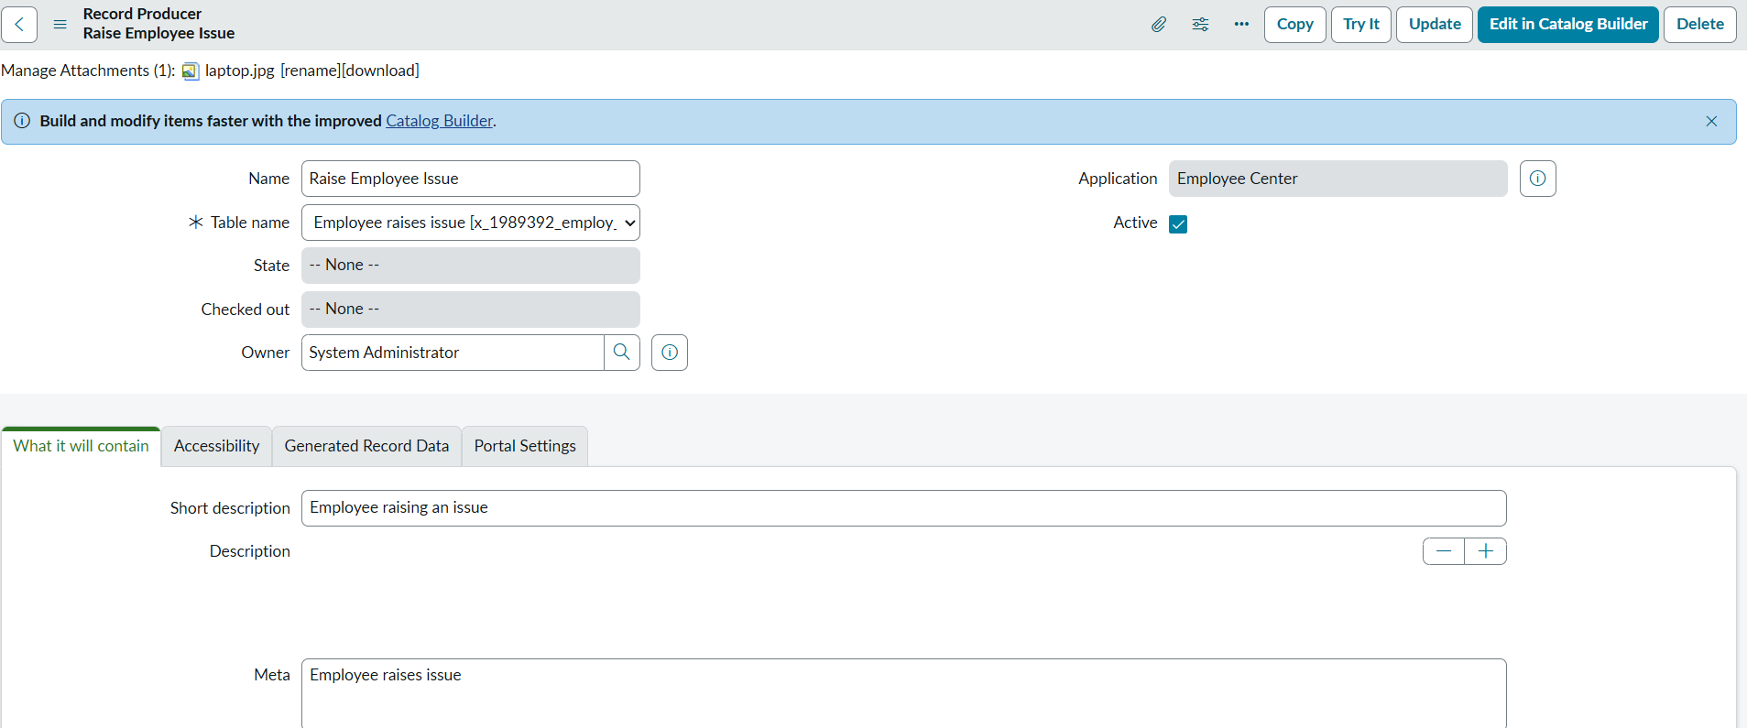

3.3 Field Configuration
Additional fields were added to the table through the form's field configuration options to capture the required issue details.
- Under Related Links, click Show Form, then open the context menu.
- Select Configure → Form Design and create the required fields with the appropriate names and types.
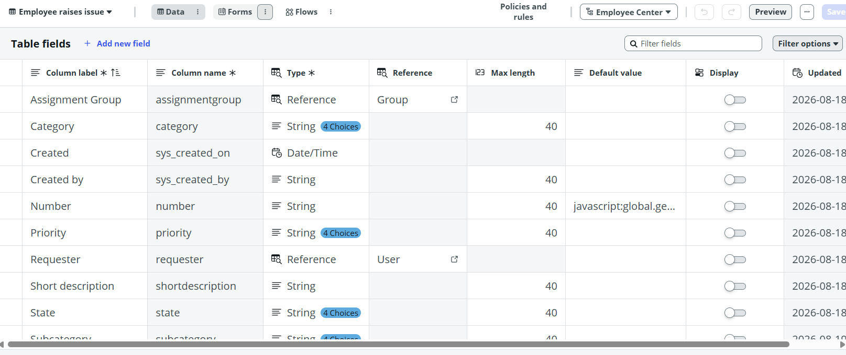

4. Phase 3 – UI Policies & Dictionary Configuration
Phase 3 enforced business rules on the Employee Issue form and configured category-dependent subcategory values.
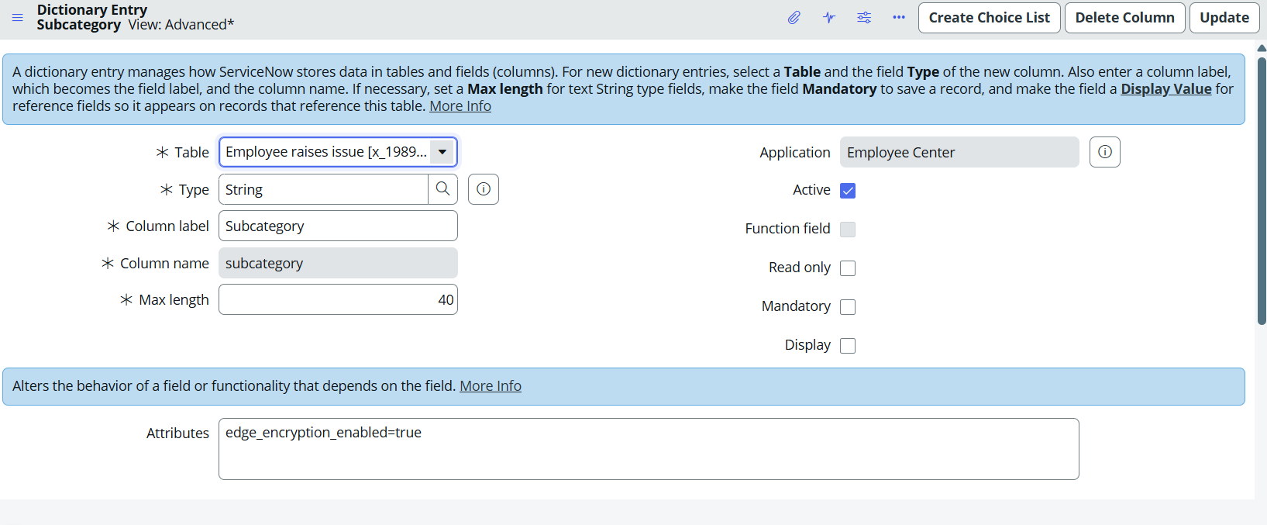

4.1 UI Policy – Mandatory Short Description
A UI Policy was configured so that the Short description field becomes mandatory whenever the State field is set to New.
- Navigate to All menus → UI Policies.
- Click New in the top-right corner to create a new UI Policy.
- Table: Employee raise issue.
- Short description: When the state changes to New, the short description is mandatory.
- Filter condition: State is New.
- Save the form, then under Related Links, open the UI Policy Action section and click New.
- Select Field: Short description.
- Mandatory: True. Visible and Read only: left unchanged.
- Click Submit, then Update.
- Reopen the form, reload, and change the State field to verify the mandatory behavior.

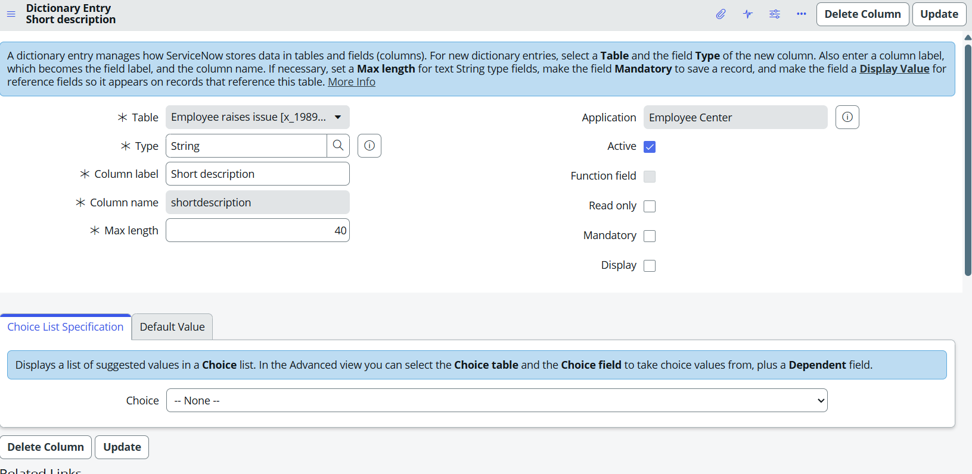

4.2 UI Policy – Read-only Number Field
A second UI Policy was configured to make the Number field read-only, without any filter condition.
- Navigate to UI Policies and click New.
- Table: Employee Raise issue.
- Short description: Number field will be read only.
- No filter condition applies.
- Save the form, then under Related List, open UI Policy Actions and click New.
- Field: Number. Read only: True. Mandatory and Visible: left unchanged.
- Submit the form, then click Update again.

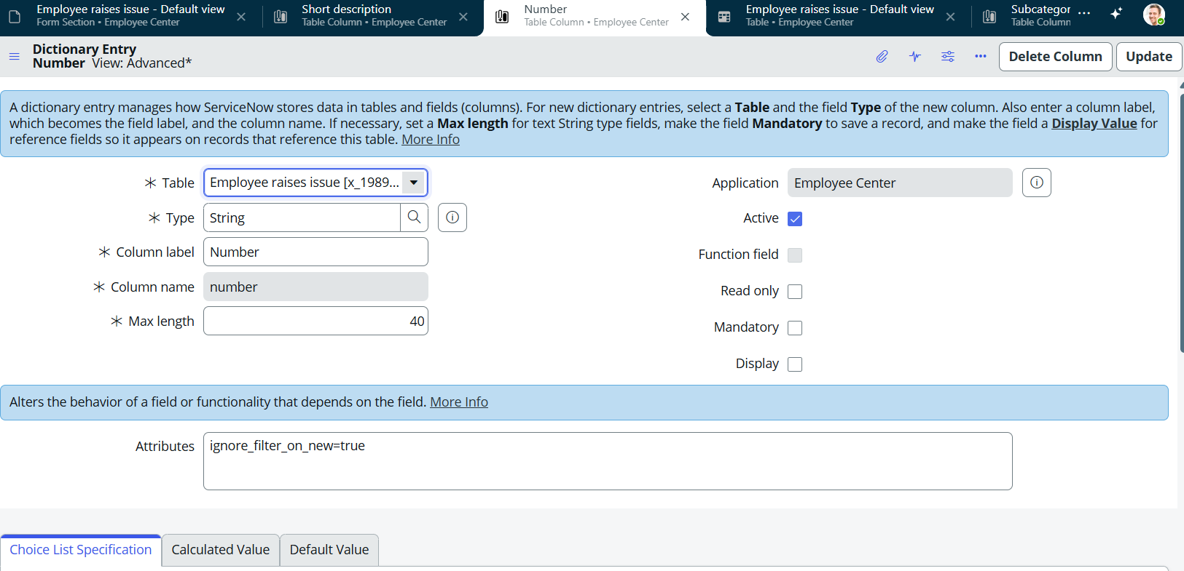

4.3 Dependent Field Configuration (Category → Subcategory)
A dictionary override was configured so that the Subcategory field displays choice values based on the selected Category value.
- Open the Employee Raise Issue table form, right-click the Subcategory field and select Configure Dictionary.
- Under Related Links, select Advanced view and set Dependent field to Category.
- Under Related Links, select the Choices section and map the backend choice values of Category to the corresponding Subcategory values.
- Category and Subcategory mapping: Network → VPN, Hardware → Laptop, Software → Server, Access → Forgot password.
- Save the form; Subcategory values now display based on the selected Category.
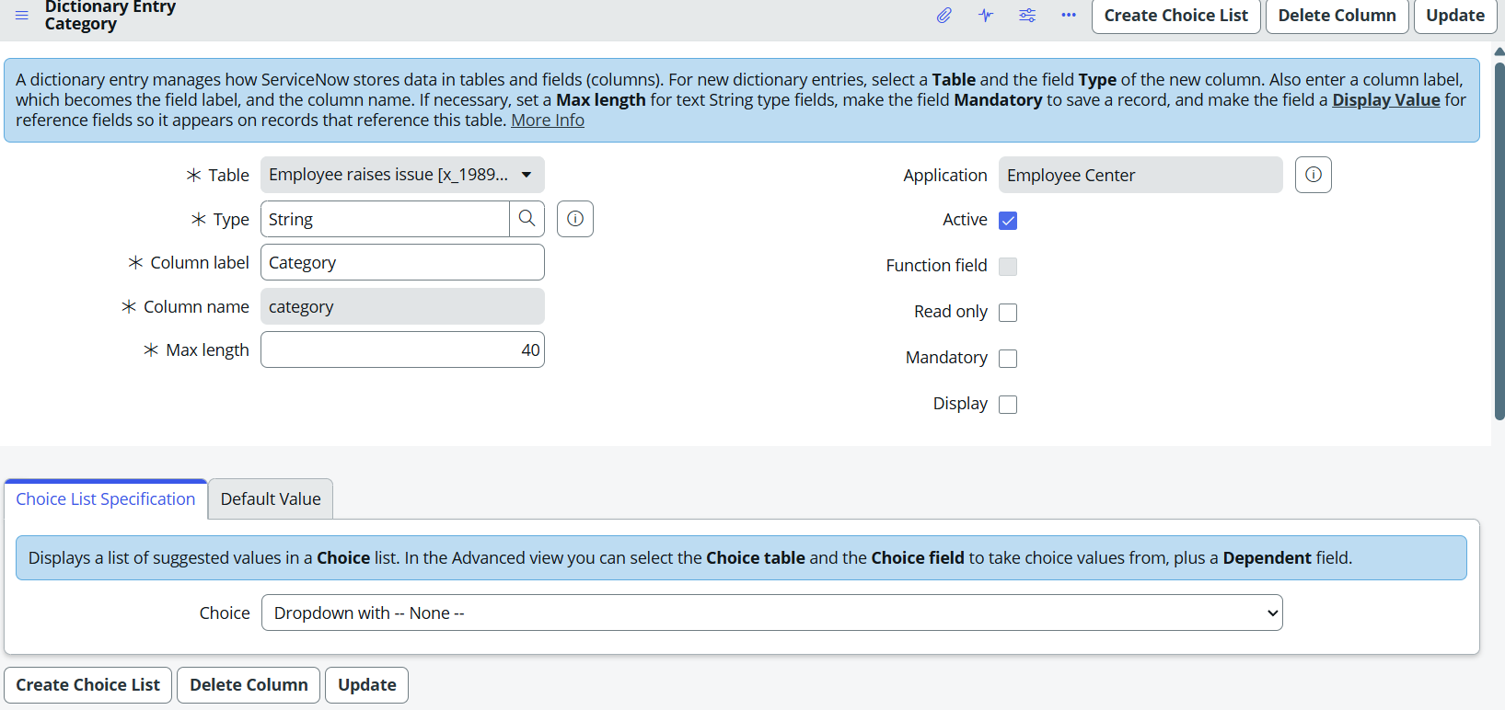
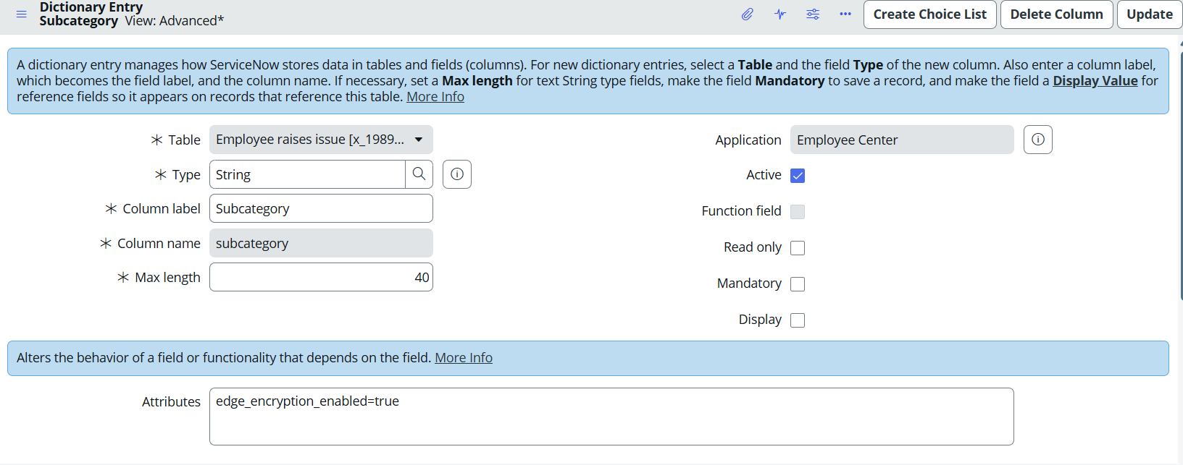

5. Phase 4 – Record Producer & Variables
Phase 4 built the Record Producer used by employees to raise an issue, with variables mapped to the Employee Issue table fields.
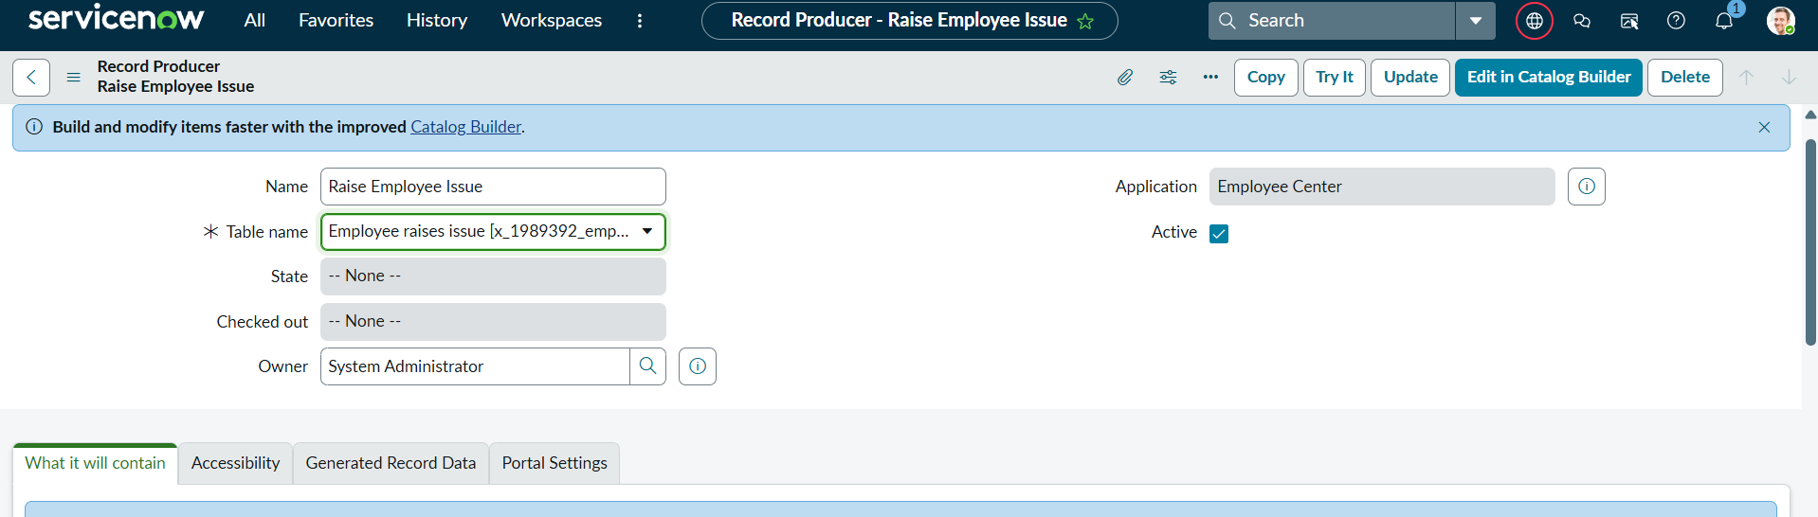

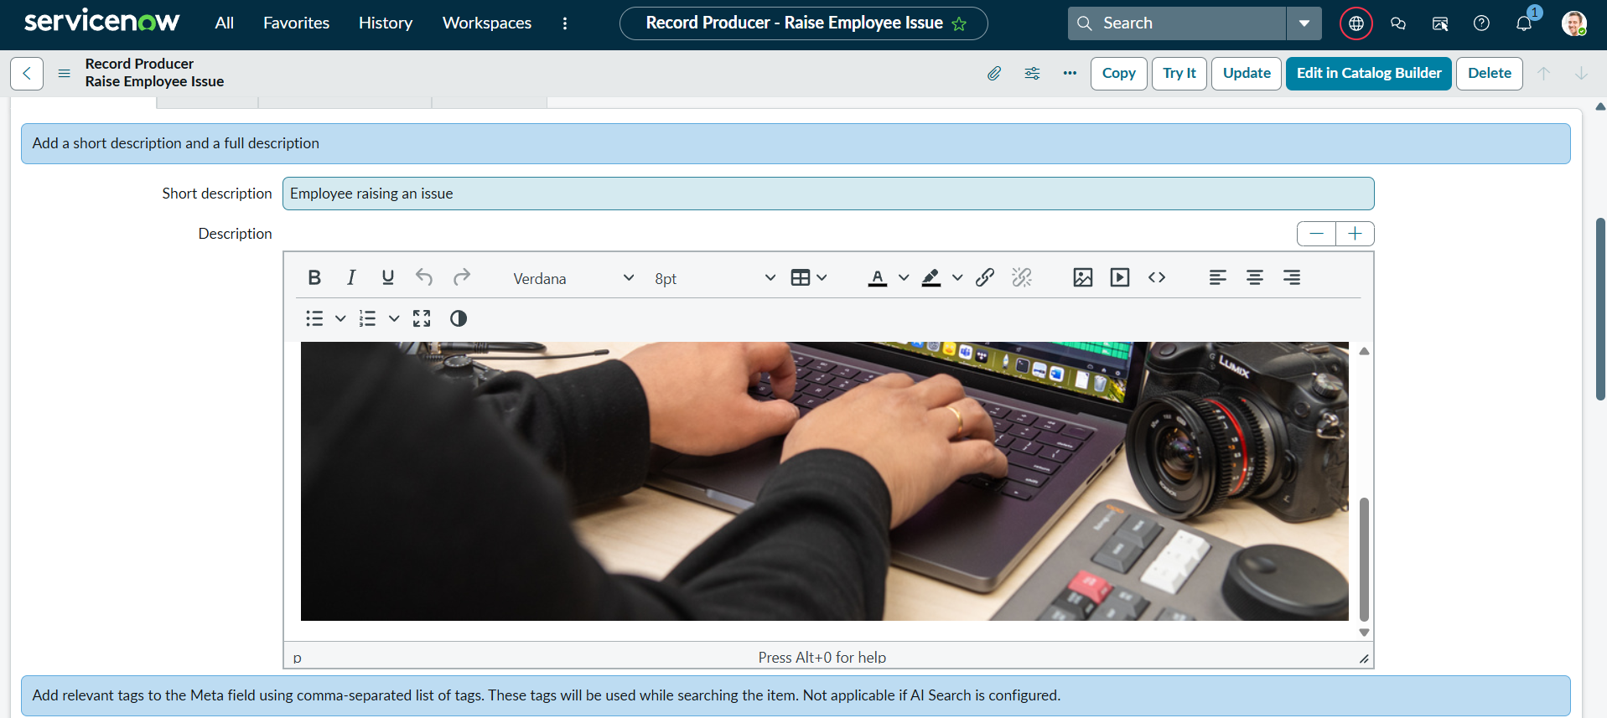
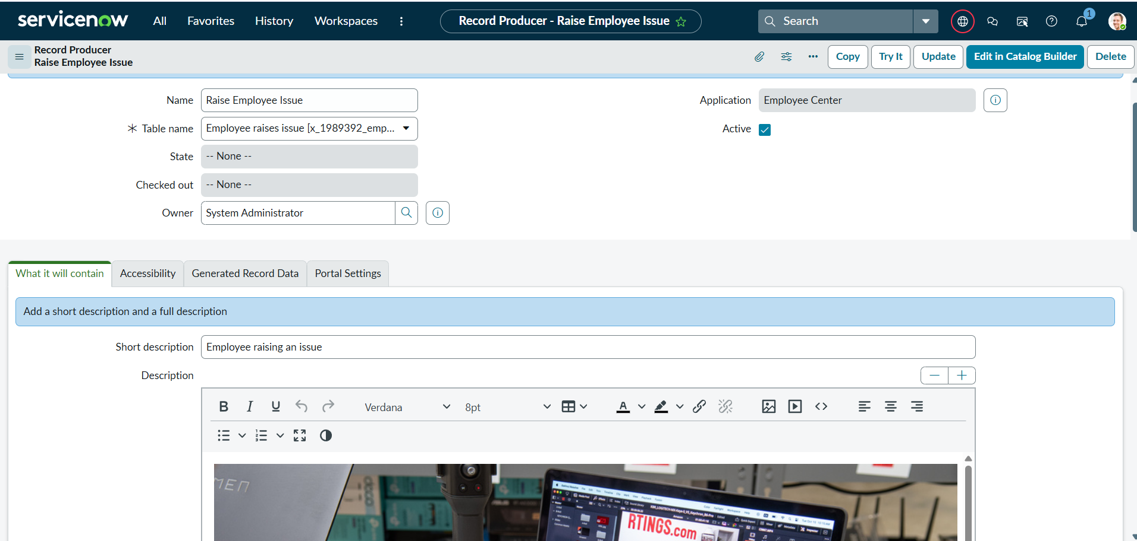

5.1 Variable Configuration
Under Related Links on the Record Producer, the Variables section was used to create fields mapped to the Employee Issue table.
- Choose the variable type based on the Employee Raise Issue table field it maps to, and enable Map to Field.
- Select the corresponding field and type, and assign an order value (100, 200, 300, ...) to each variable.
- Complete the Question field for each variable; the Name field auto-populates.
- Repeat to create the five variables listed below, then save the Record Producer.
Variable | Type | Notes
Requester | Reference (sys_user) | Auto-populated / selectable employee reference
Category | Choice | Network, Software, Hardware, Access
Subcategory | Choice | VPN, Laptop, Server, Forgot password (dependent on Category)
State | Choice | New, In Progress, Resolved, Closed
Short description | Single line text | String

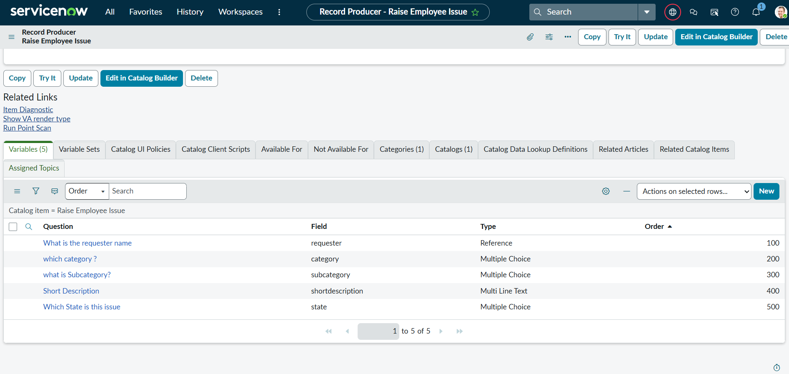

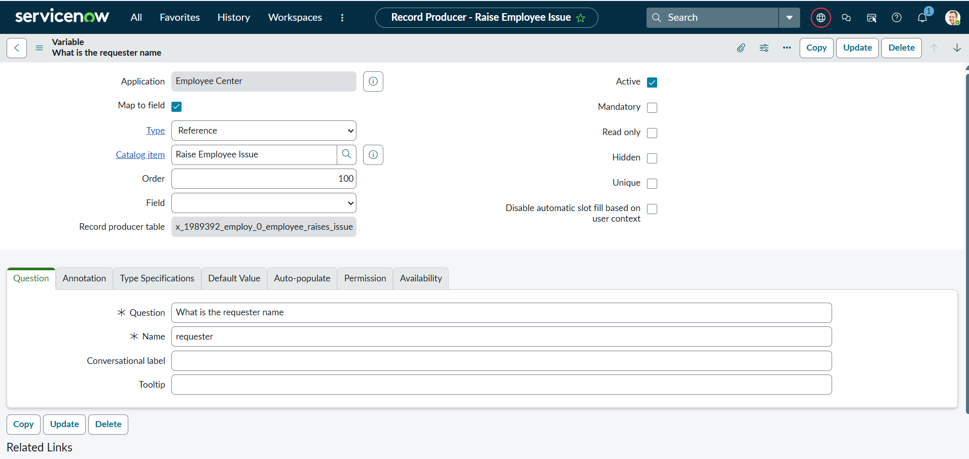

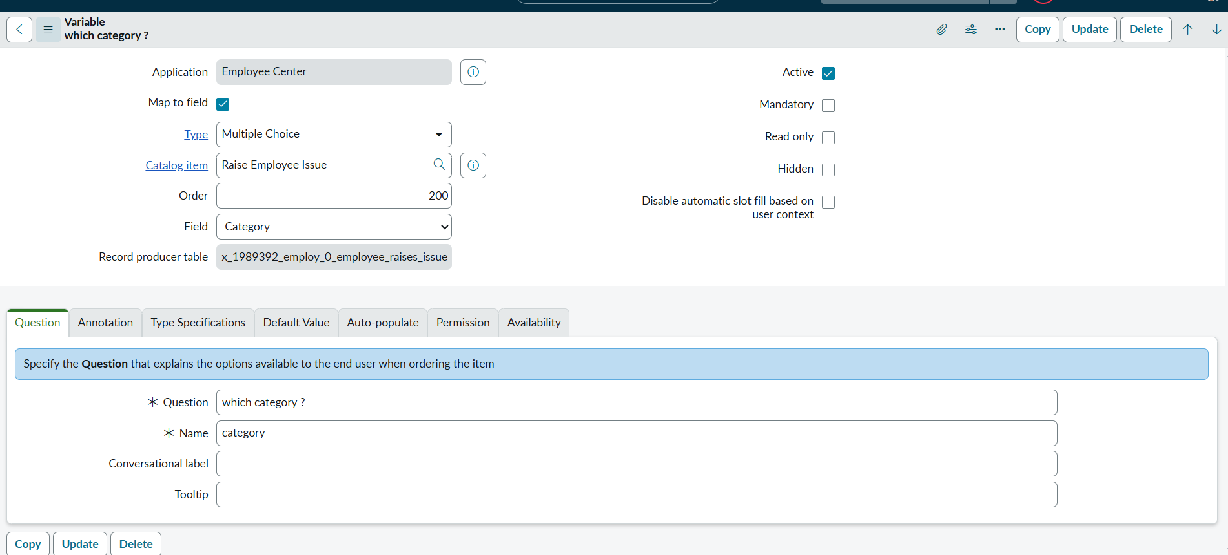

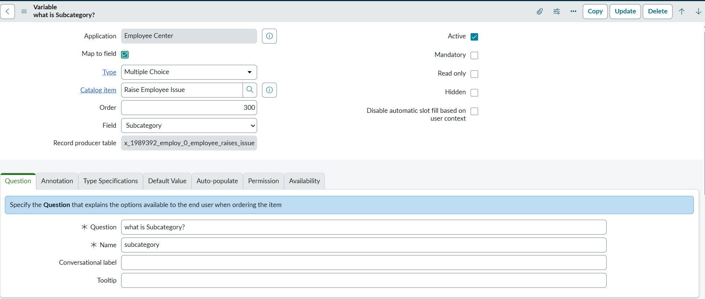

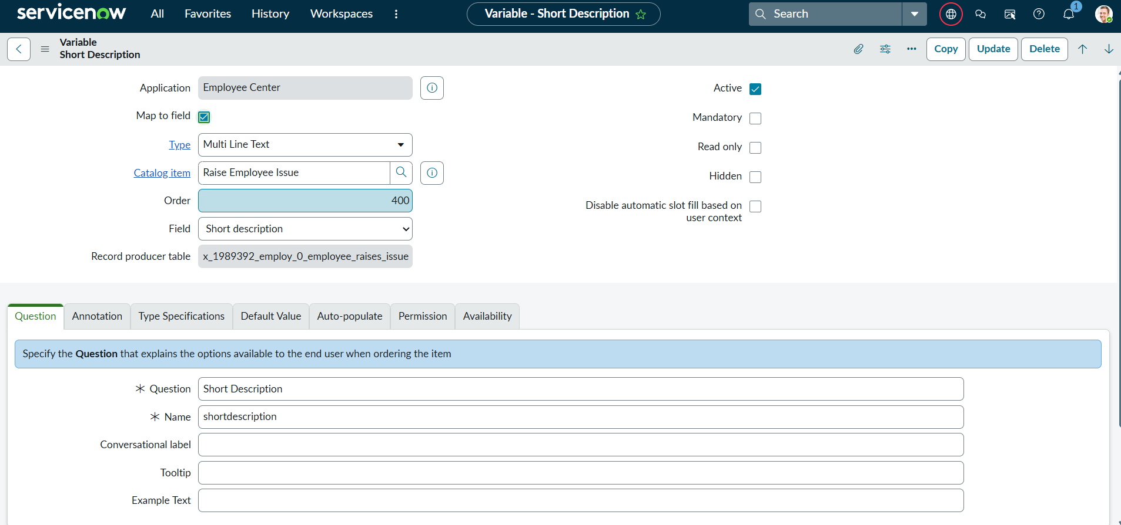

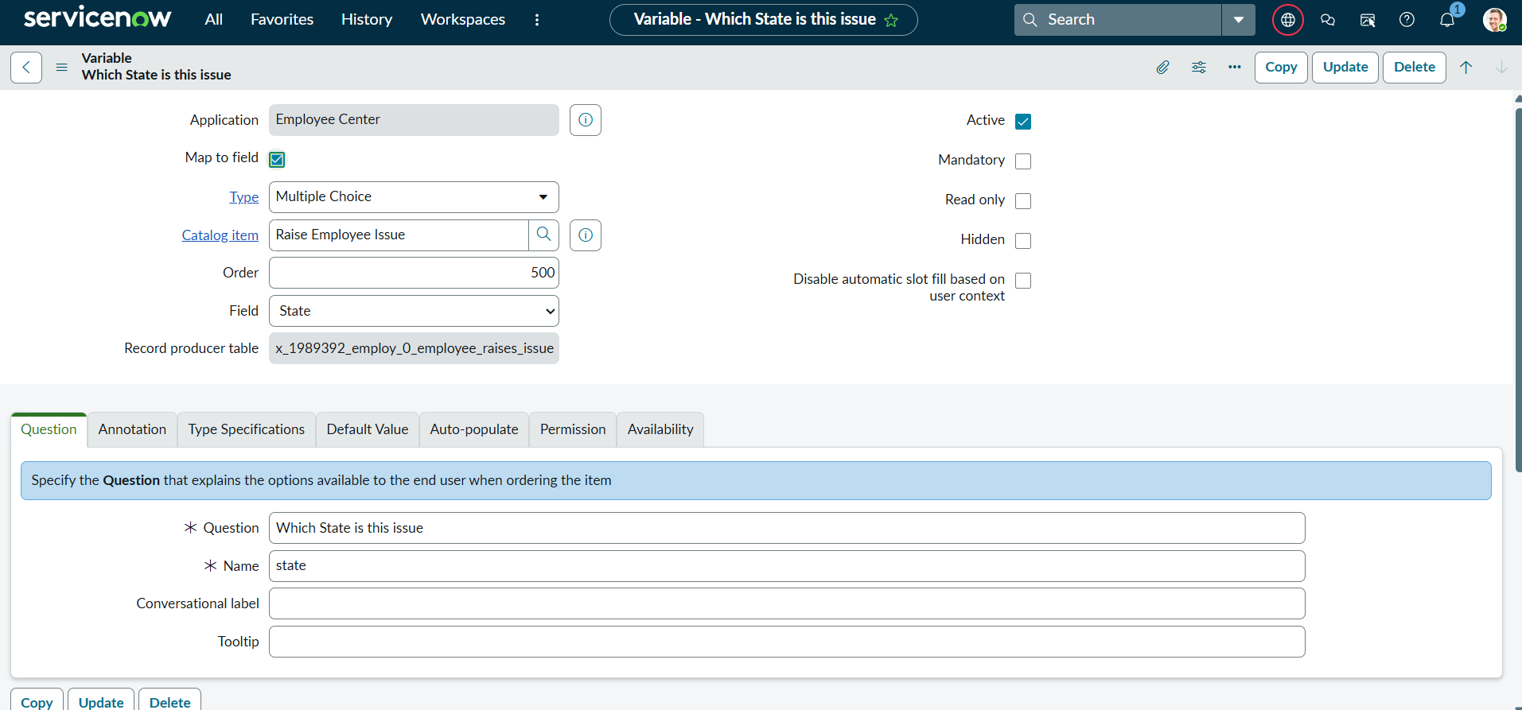6. Phase 5 – Service Portal Development
Phase 5 built the Employee Center Service Portal, the widgets used on its homepage, and the page layout that ties the portal together.

6.1 Service Portal Configuration
- Navigate to Service Portal Configuration under Service Portal.
- Click New in the top-right corner to create a new portal.
- Title: Requesting portal.
- URL suffix: employee_request.
- Homepage: ec_standard_home.
- KB Homepage: esc_knowledge_home.
- Login page: login.
- Logo: upload the desired image.
- Main menu: Employee Center Menu.
- 404 Page: 404.
- Theme: Employee Center Coral Theme.

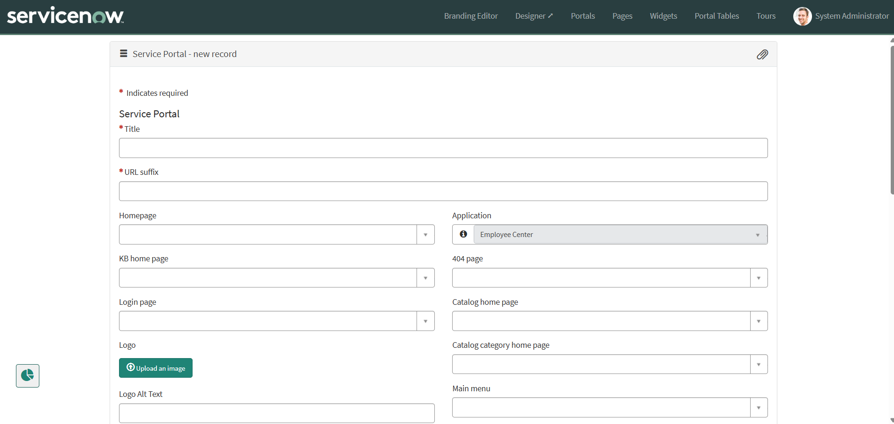

6.2 Widget Development
Two custom widgets were built using the Widget Editor to enhance the portal homepage.
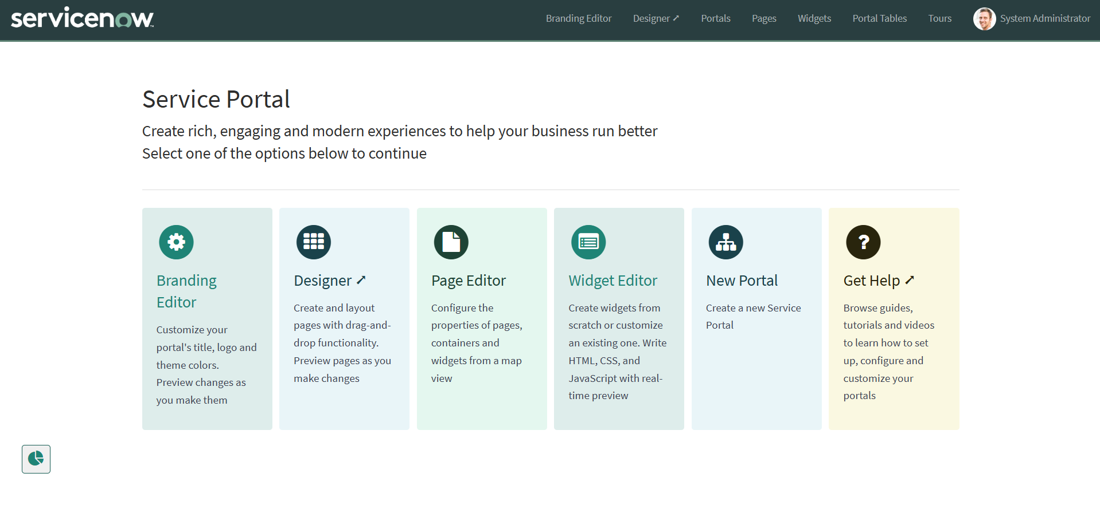

Widget 1 – Commercial Widget
- Navigate to Service Portal Configuration → Service Portals → Widget Editor.
- Click Create a new widget and name it Commercial widget, then click Submit.
- Write the HTML and CSS for the widget, enabling the template preview for each section.
- Use the eye icon to toggle Preview / Hide.
- This widget presents a floating text effect that responds to cursor movement.

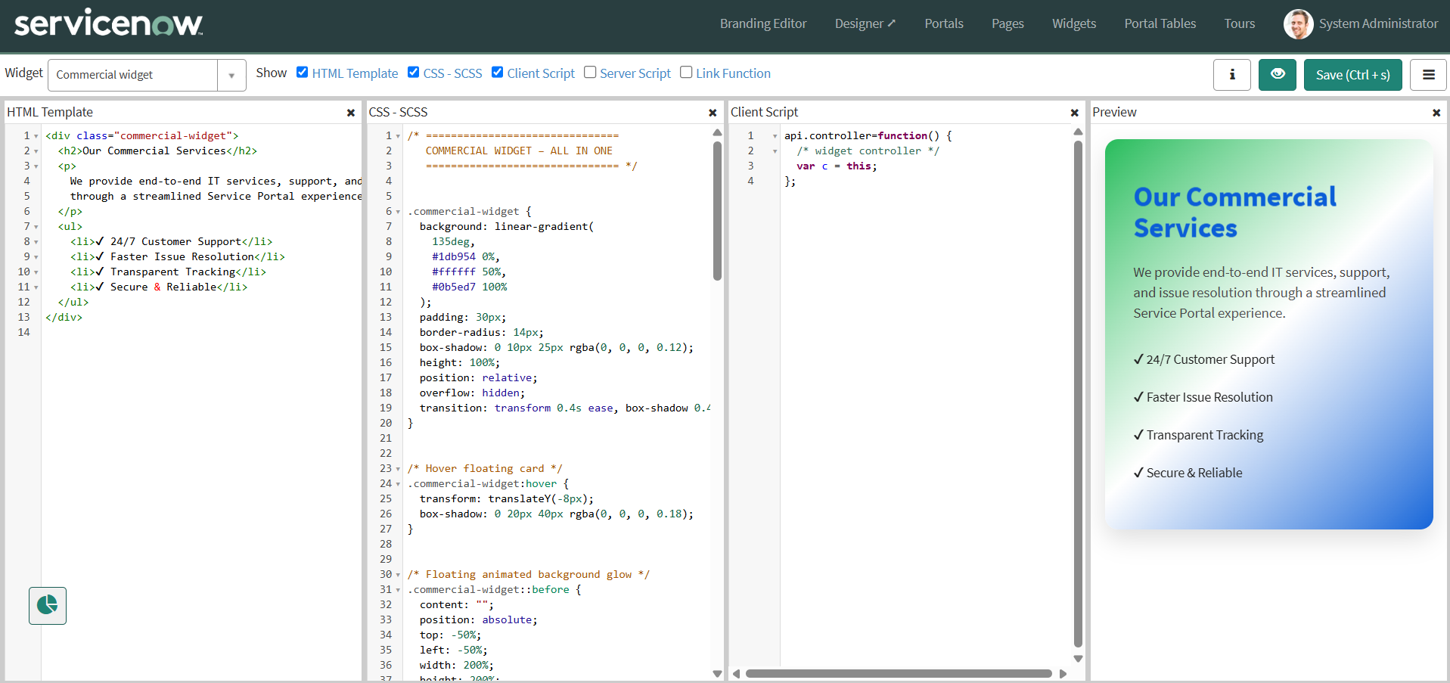

Widget 2 – Link Redirect Widget
- Navigate to Service Portal Configuration → Service Portals → Widget Editor.
- Click Create a new widget and name it Link redirect, then click Submit.
- Write the HTML, CSS and Client Script for the widget.
- Use the Client Script to redirect the page to the Record Producer using its sys_id.
- Enable the template preview for each section and use the eye icon to toggle Preview / Hide.
- This widget presents a floating and premium-styled text effect that responds to cursor movement.
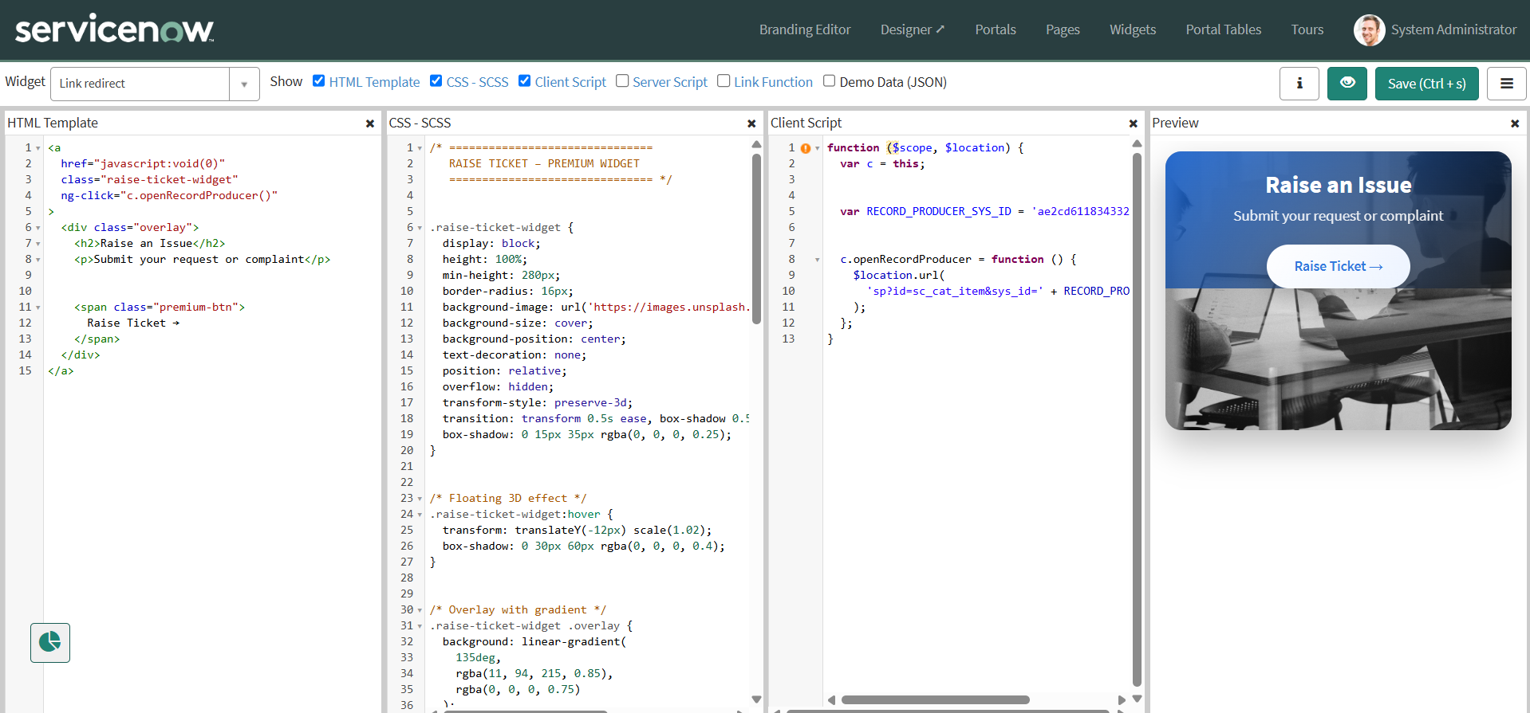

6.3 Page Design
The two widgets were placed on the existing Employee Center Homepage using the Service Portal Designer.
- Navigate to Service Portal Configuration → Service Portal → Designer.
- Search for the Employee Center Homepage and select it.
- Create a container with a 6×6 column layout.
- Search for the widgets and drag and drop them into position based on where they should display.

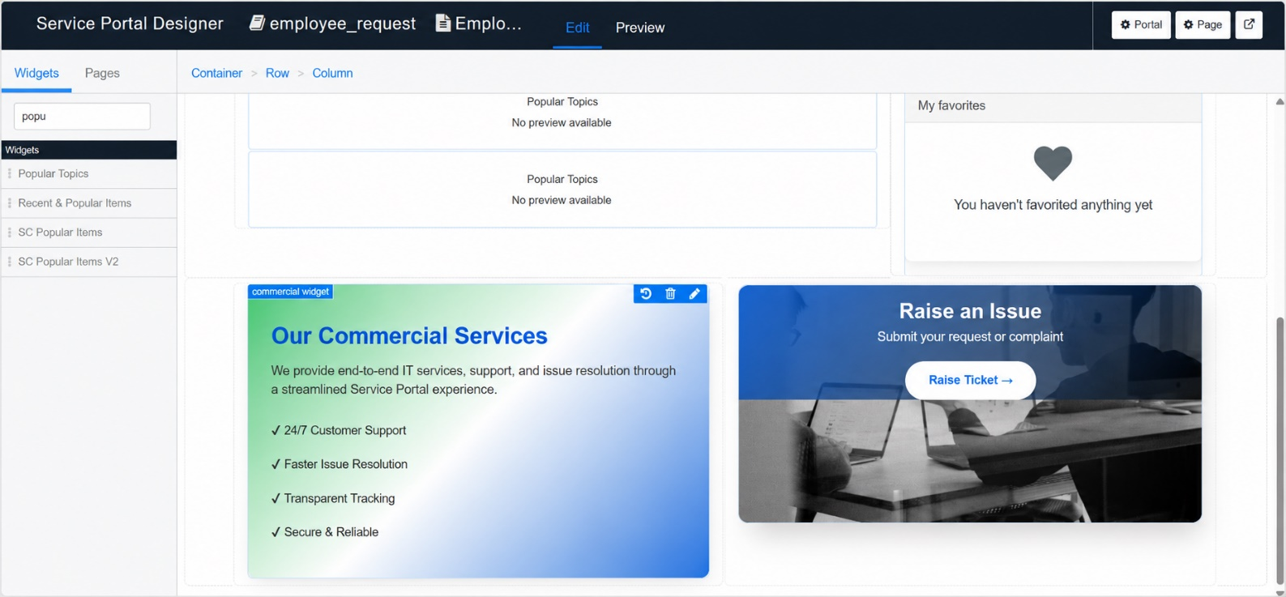

7. Phase 6 – Testing & Validation
End-to-end testing verified the Employee Center portal, the widgets, the Record Producer, and the configured UI Policies and dictionary override.
- Open a new browser tab and navigate to https://dev280178.service-now.com/employee_request.
- Observe the logo image and icon that were added to the portal.
- Press Enter and scroll down to view the widgets created on the homepage.
- Move the cursor to observe the floating effect of the two widgets.
- Click the Link button to open the Rise ticket action, which opens the Record Producer.
- Fill in the employee and issue details in the Record Producer, then click Submit.
- Observe the field behavior and restrictions enforced by the configured UI Policies and dictionary override.

8. Project Conclusion
By implementing a custom scoped application, custom table, UI Policies, Record Producer, and a dedicated Service Portal, the solution ensures the following outcomes:
- Standardized and accurate issue submission.
- Enforcement of business rules through UI Policies.
- Controlled category and subcategory selection.
- Seamless integration between the Service Portal and backend records.
- Improved visibility and faster issue resolution.
End-to-end testing and validation confirmed that the solution is stable, reliable, and aligned with real-world business requirements. This implementation reduces manual effort, minimizes data inconsistencies, and enhances the overall employee experience.

